

-2026)
Dr. Jayaram Boga
L. Sainath
2520090148
CSIT
C0 -2 Multiway Trees & Range Query Structures

Case Study Topic: Sports Statistics Analytics using B-Trees, B+ Trees, Segment Trees & Fenwick Trees
Work Done Summary:
In this case study, we implemented advanced indexing and range-query data structures to manage athlete performance statistics. B-Trees and B+ Trees were used for efficient storage and retrieval of performance records. Segment Trees and Fenwick Trees were applied to perform range-based analytics and cumulative scoring operations.
Implementation Details:

Indexed athlete performance records using B-Trees.

Implemented B+ Trees for range queries on match scores and statistics.

Built Segment Trees to analyze seasonal performance trends.

Used Fenwick Trees to compute cumulative athlete scores efficiently.

Performed range sum and interval queries on performance data.

Compared query efficiency across different data structures.

Result: Screenshot/Output
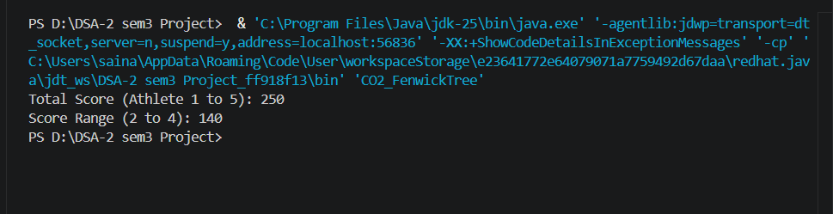
- Performance statistics were indexed efficiently.
- Range queries on scores and rankings were executed quickly.
- Seasonal analytics and cumulative score calculations were generated successfully.
Time Complexity:
- B-Tree Search: O(log n)
- B+ Tree Range Query: O(log n + k)
- Segment Tree Query: O(log n)
- Fenwick Tree Update/Query: O(log n)

GitHub Link: https://github.com/Sainath5689/DSA-2-SEM3-PROJECT

